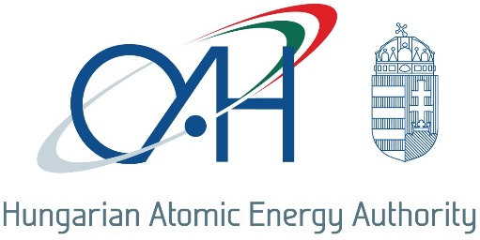

Statement about radioactive source event
On 21st January 2019, at 8:00 pm a well-logging geophysical probe containing 239 GBq activity ²⁴¹Am-Be sealed source was dropped to the bottom of a1800 m deep well near Pecs city, Hungary. The cause of the event was the break of the probe head due to material failure. The license holder responsible for handling the radioactive source and performing the well-logging probe informed the regulatory body about the event on 22nd January 2019. After preparation, the regulatory body performed an in-field inspection on 24th January 2019. During the inspection, the measurements of the drilling sludge, the well and the vicinity of the wellhead showed no traces of ²⁴¹Am contamination, which indicated that the source remained intact. The break of the probe head was in such a place that the available emergency probe retrieving equipment (overshot assembly) and procedure could not be used immediately. During the inspection, it was also found that one of the three licenses required to perform such a well-logging geophysical measurement was not valid.
The successful retrieval of the sealed source was only possible on 6th February 2019, using a modified retrieval technology based on the approval and oversight of the regulatory body with the involvement of a subcontractor licensed for such an activity.
According to the first results of the measurements and the in-filed inspections, the sealed source was safely recovered and no indication of radioactive material release into the environment was found. During the event, the radioactive source did not pose any risk to the public and the environment, since the well and its vicinity was under strict control and no contamination occurred.
The regulatory body indicated a procedure to investigate the event and conduct an enforcement procedure against the license holder performing the well-logging geophysical probe. As the license for application of radioactive material was not effective at the time of the event, and the new license was not yet issued by the regulatory body, this circumstance was identified as a safety culture issue / deficiency.
Although the event had no consequences to the environment and to the public, due to the fact that the safety provisions ensuring the safety of the radioactive source were partially degraded and the safety culture deficiency was identified, the event was rated in INES scale as INES 1 (Anomaly).

